Intelligent Virtual Career Advisor

Details Functionalities :-

1. Skills assessment ➖

=> User’s skill sets

* Based on skills

-> first take quizzes based on given skill (gemini llm)

-> two options :-

- if the quiz is successfully completed based on required then suggested courses, roadmaps, projects etc.

-if the quiz is not satisfied then first give a response that first worked on your skill.

-> based on skills completed also give recommendation of jobs, also do updates on resume and also update on dashboard.

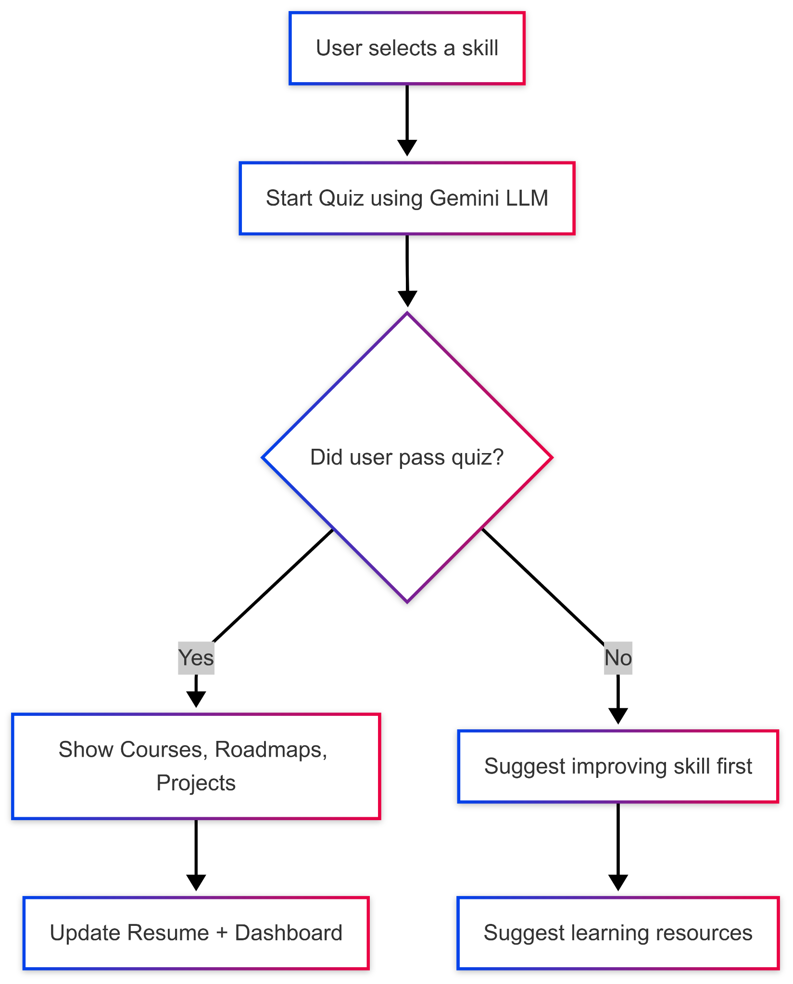

1. Job market analysis

-> based on the current job market and skills give suggestions to which skills are required and which skills have more scope with the job.

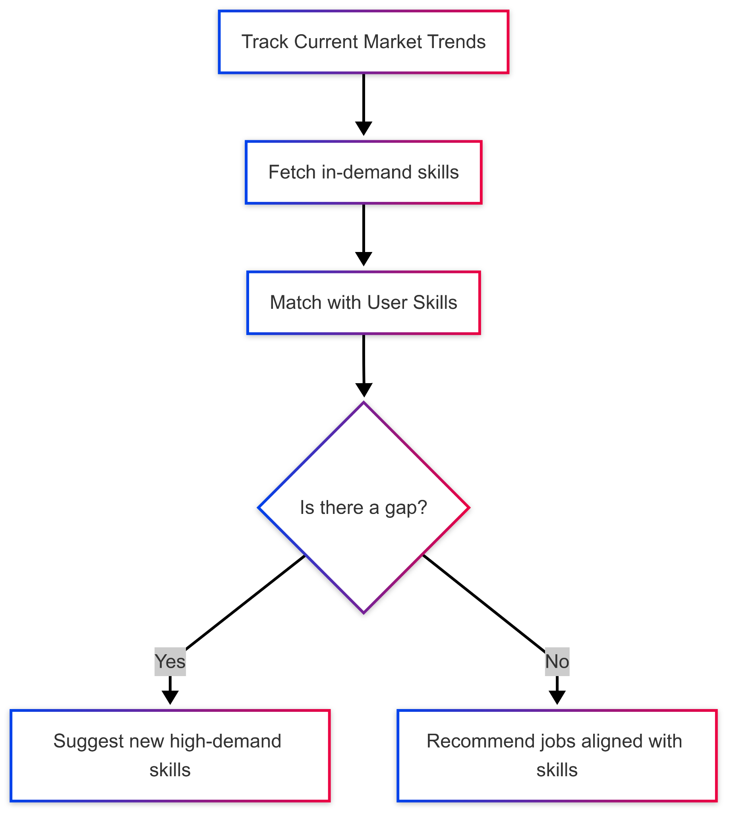

1. Resume and interview tips

-> build auto resume by completed courses, skills and projects

-> also give tips on resumes if the user is built on their own .

-> interview tips

(extra first asked quiz of previous interview and asked about how experience that based on give tips)

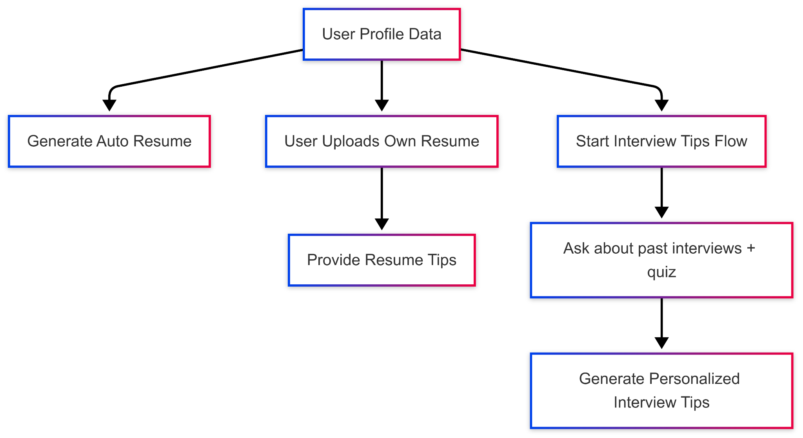

1. Personalized career path recommendations

-> same as the first recommendations on skills and courses of the current era.

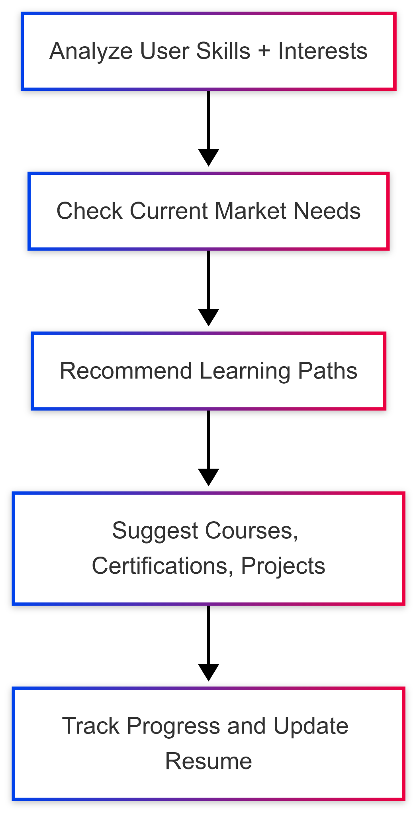

5 . Integrated network analysis

-> Based on linkedin connections, give analysis which occupations have already joined with you and how do you approach that.

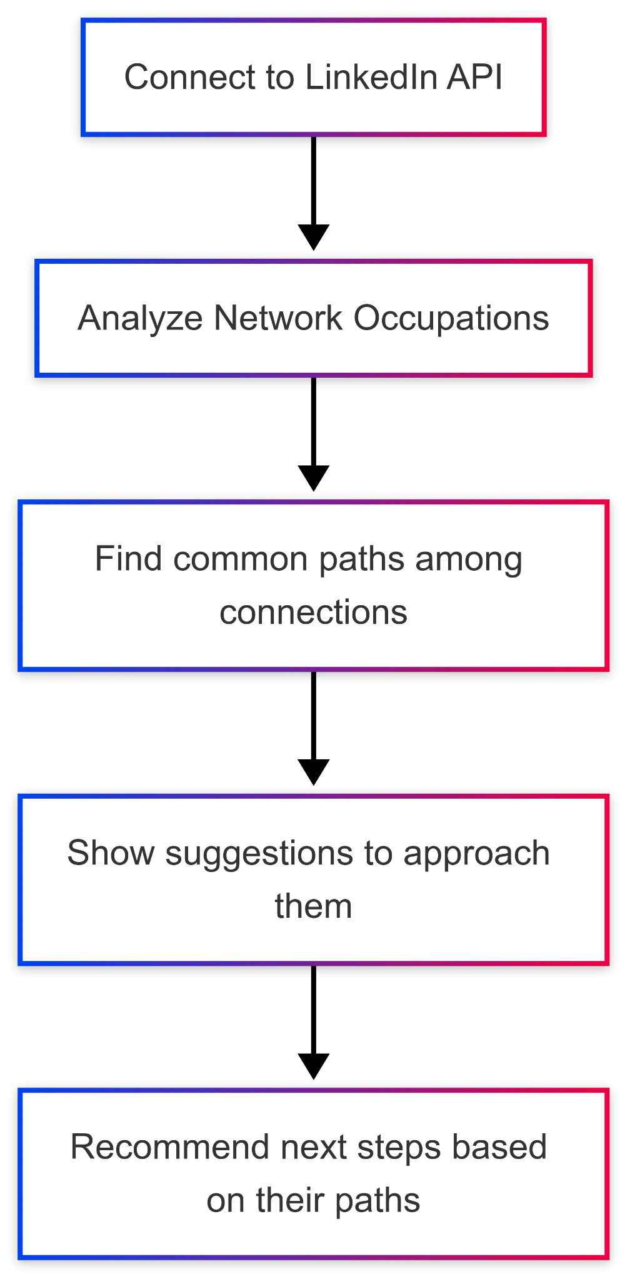

=> Future planning :-

-> add Nft badge generate,gamifications

-> See you near occupation people like 10km near sundar pichai(ceo of google)

->

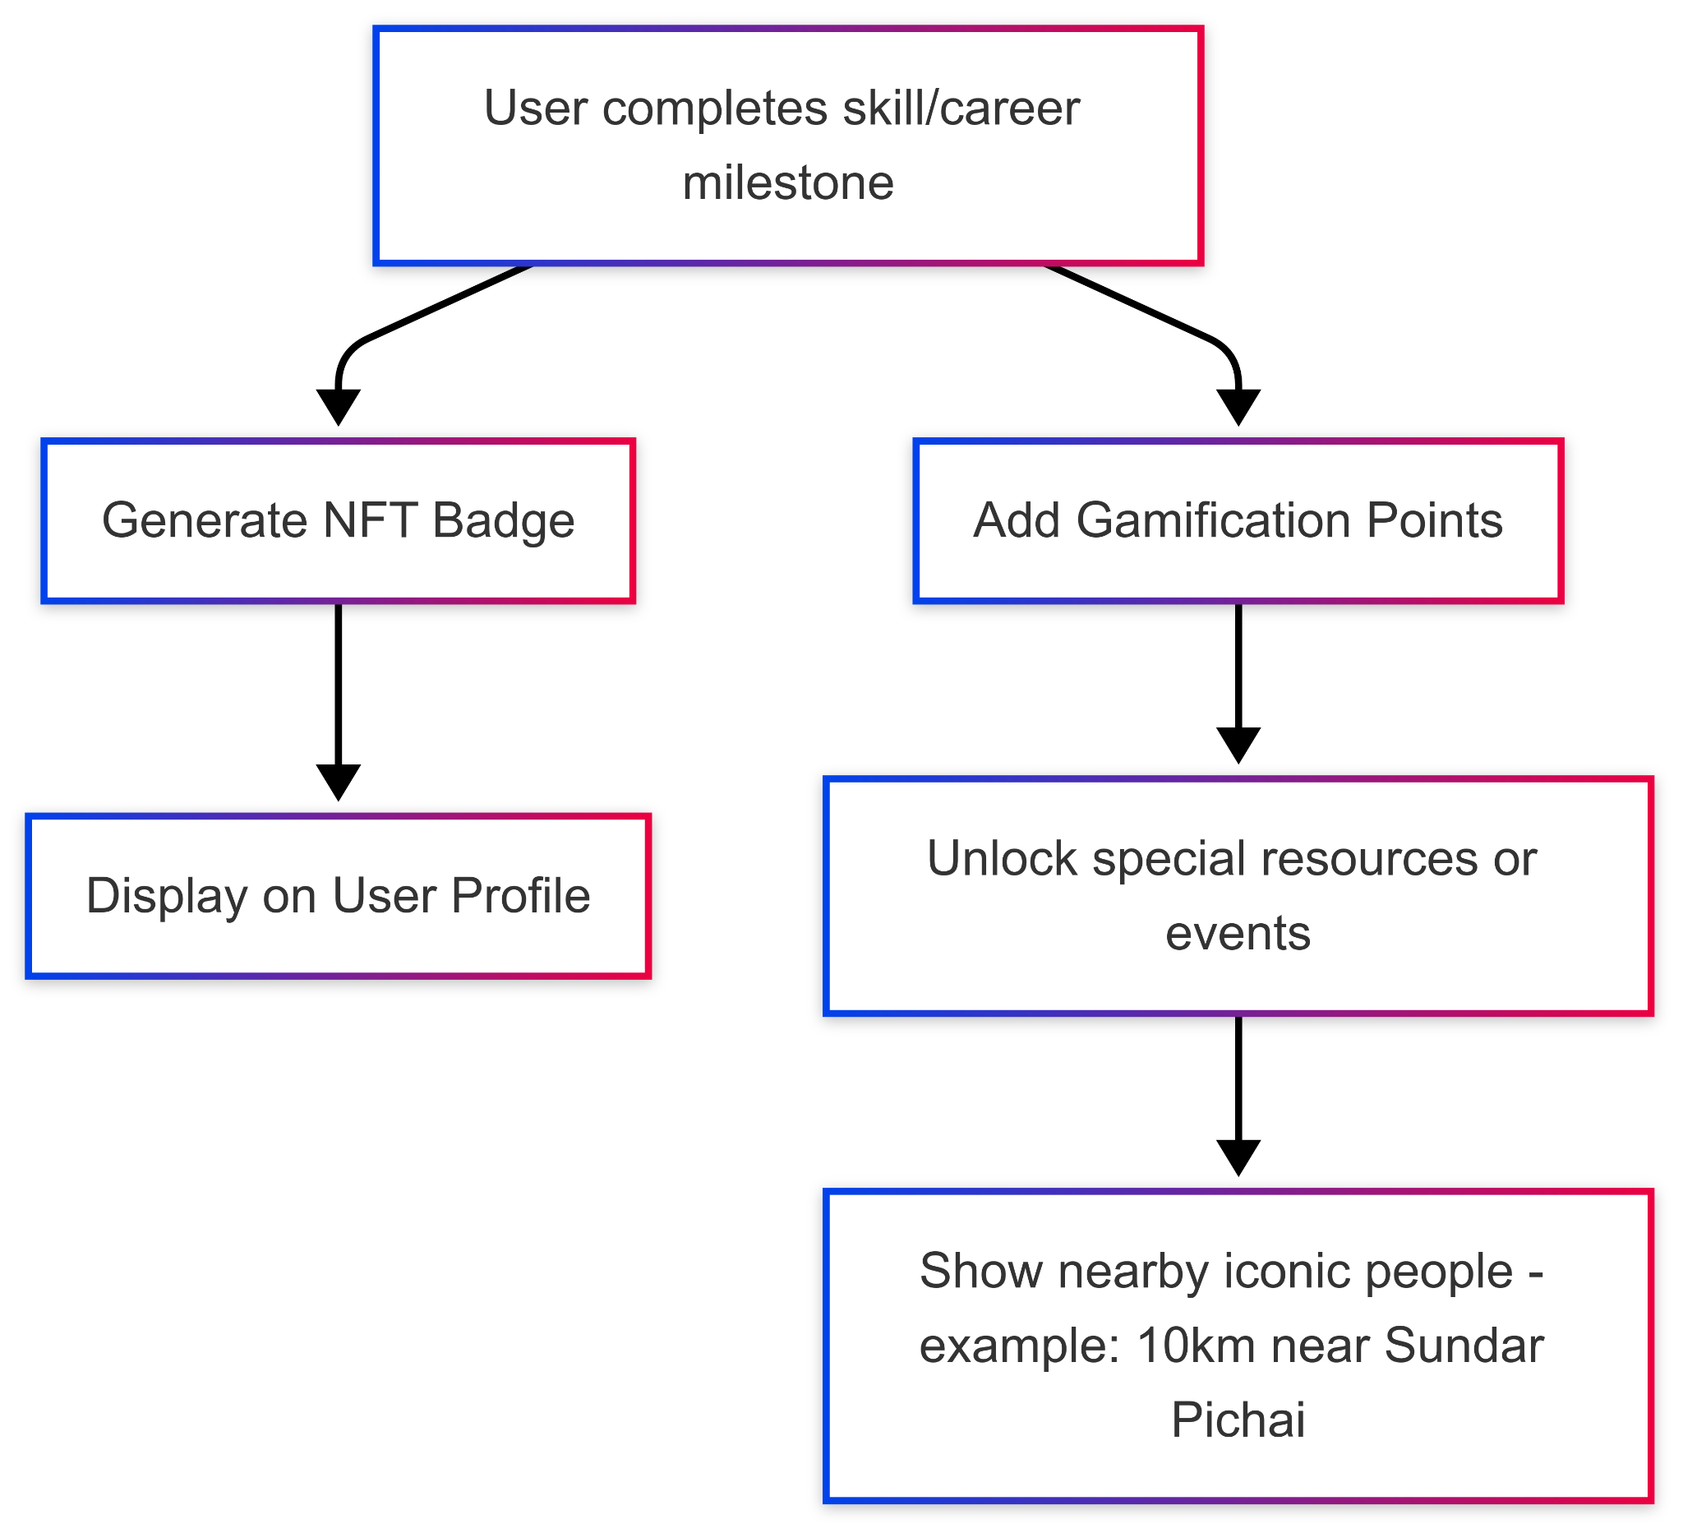

=> final showdown

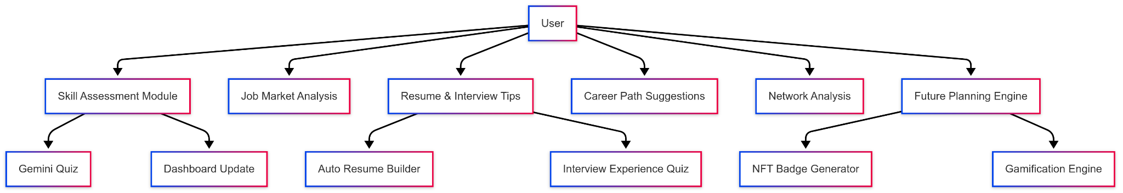

=> day one 12/4 4pm

Dashboard: profile data, resume, ats score, weighted skills graph, certificate, professional links

* Future :-
  + Subscription model,
  + Bookmarks, followings, starts,

=> todo

* Code formatter in quiz ai